5D4N Beijing-Shanghai Tour

Period : August 2019-- Feb, 2020
Pax : 10+1Foc，15+1foc;20/25+1foc
Hotel : Local 4 star or similar
Meal : Normal meal

D1:Beijing (--/L/D) ETA in the morning
Upon arrival in Beijing, meet the local services,visit Tian An Men Square, Forbidden City,Summer Palace,Acrobatic Show. After dinner go to hotel.
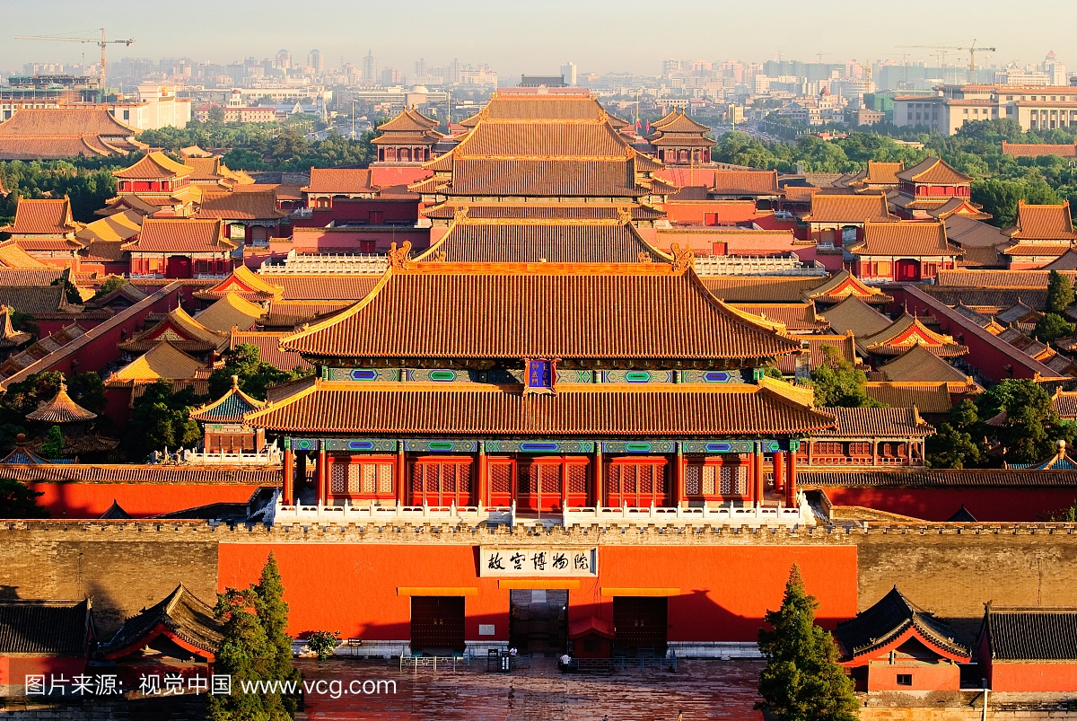
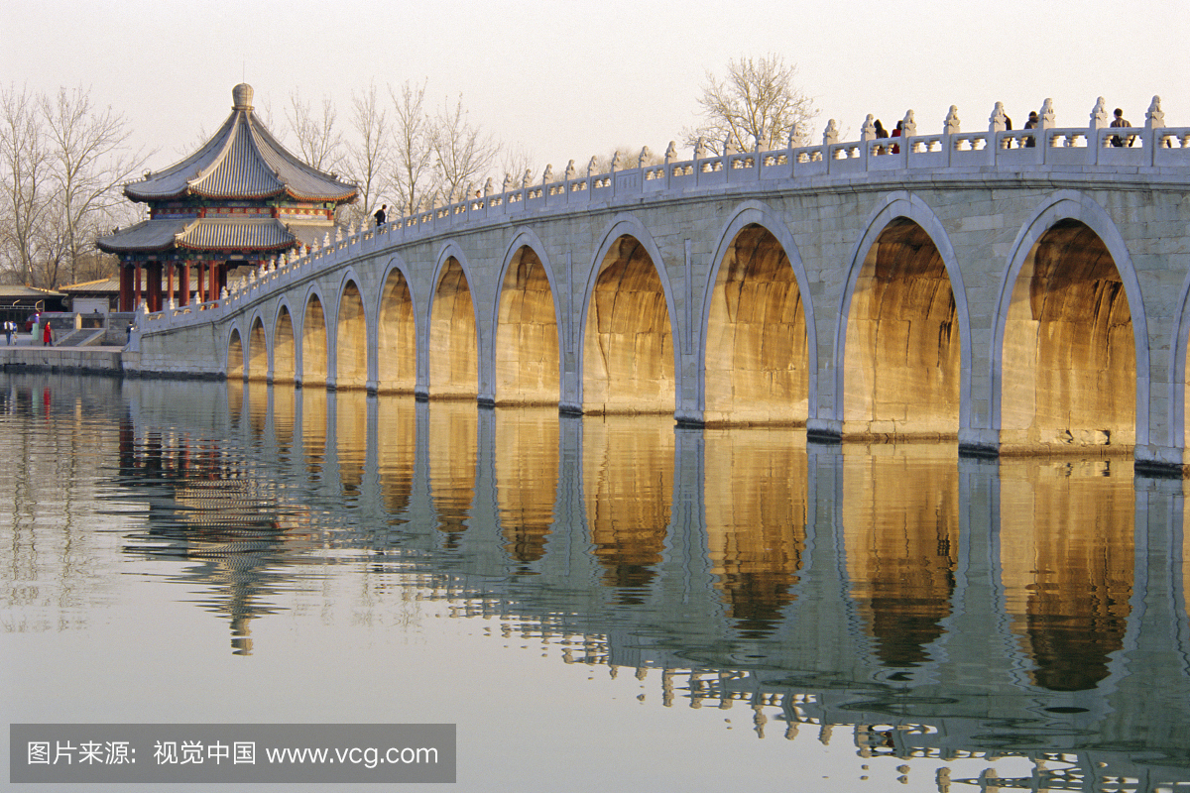
D2: Beijing (B/L/D)
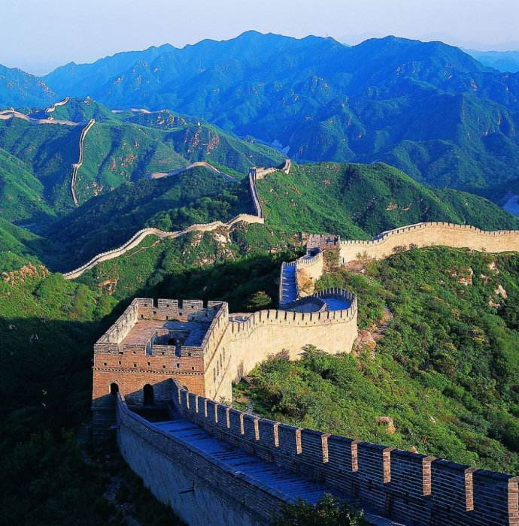
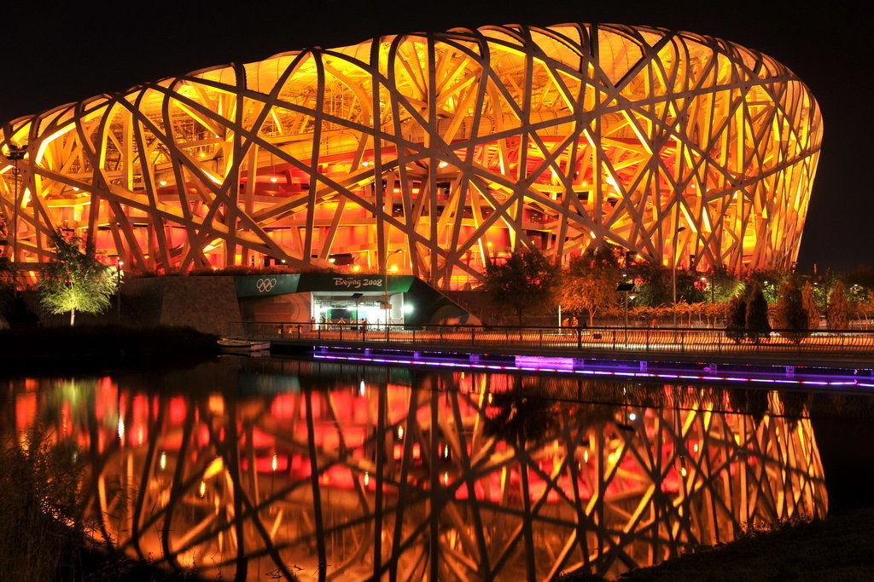
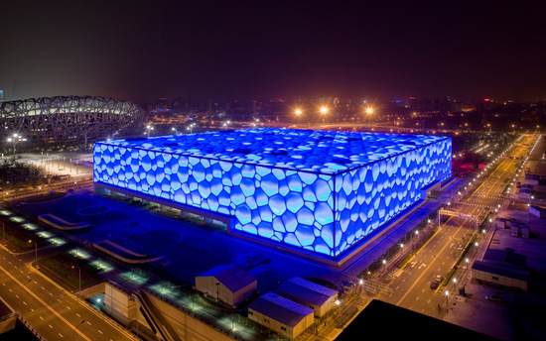
After Breakfast in the hotel,visit Great Wall,outside Beijing 2008 Olympic National Stadium (Bird Nest& Water Cube),Dinner with Peking Roast Duck . After dinner go to hotel.
D3: Beijing-Shanghai (B/L/D) by 2nd Bullet Train 5h
After Breakfast in the hotel,transfer to Shanghai,visit The Bund,Nanjing Road,Outside Oriental Pearl TV Tower for photo stop,Chenghuangmiao Mall.After dinner go to hotel.
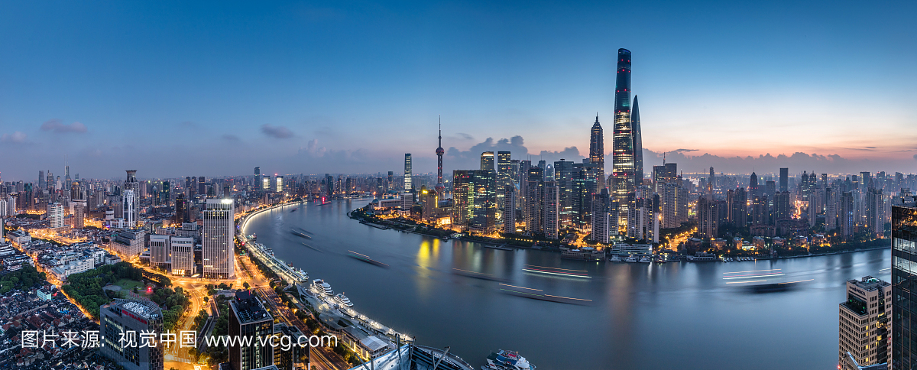
D4:Shanghai (B)
Full free day in Shanghai Disneyland.

D5: Shanghai-Departure (B/-/-)
After Breakfast in the hotel,transfer to the airport and end the tour.

Shopping stop:
Beijing: Chinese Medicine Center (Foot Bath), Baoshutang, Latex,Bamboo charcoal.
Shanghai:Jewelry
Hotel 4****local or similar
Beijing: Apple Hotel or similar
www.sijiapplehotel.com
Shanghai:Jilei International Hotel or similar
http://hotels.ctrip.com/hotel/8510633.html?isFull=F

August --Oct,2019
PAX | Local 4 STAR (per pax)
PAX | TWN（USD） | SGL SUPL（USD） | CWB(USD) | CNB(USD)
10+1Foc | 170 | 85 | 160 | 130
15+1 Foc | 125 | 85 | 120 | 100
20/25+1 Foc | 120 | 85 | 110 | 80

Nov,2019 -- Feb,2020
PAX | Local 4 STAR (per pax)
PAX | TWN（USD） | SGL SUPL（USD） | CWB(USD) | CNB(USD)
10+1Foc | 160 | 75 | 150 | 120
15+1 Foc | 115 | 75 | 105 | 90
20/25+1 Foc | 105 | 75 | 95 | 80

The above quotation included:
1. Transfer in/out
2. Meals
3. Indonesian speaking guide and entrance fee
4. Accommodate in local 4 star hotel
5. Free 1 Bottle of water /Pax/day
6. Accident Insurance
7. Peking Roast Duck

The above quotation excluded:
1. International flight ticket and airport tax
2. Tips for the guide and driver 4USD/Day/Pax. (Above 10 pax)
3. Tips for potter, waitress & Luggage’s fee
4. Personal consumptions & expenses (laundry, phone, mini bar, etc)
5.2nd Bullet ticket Beijing-Shanghai:85USD/pax no foc.
6 Entrance fee of Shanghai Disneyland on Summer Holiday (July--August) & Weekend $85/pax No Foc.
On weekday $60/pax No Foc.

